CC/MM : Convitto Cagliari / Marcellin Melbourne
- Alessandro Corda: 17 July, 2019 - 27 August, 2019

Two premises:
- As far as my experience is concerned, I could not have asked for anything better.
- If I could have stayed there I wouldn’t have thought twice !!
It all started here…….........

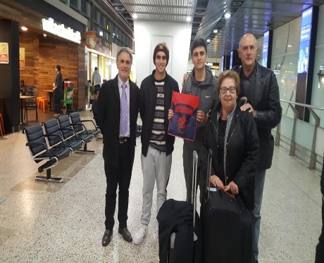

The family Broggian welcomed me as a son , without any distinction, showing me the attention I needed day after day . It was wonderful to observe the relationship of trust and honesty that was established immediately through the small things, the daily conversations during breakfast or in the evening at dinner.

Matthew and I became friends instantly and our friendship was immediately frank and sincere but above all we were in tune on everything.

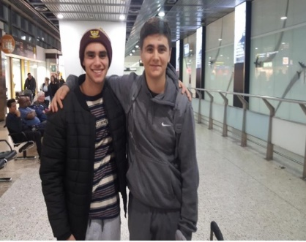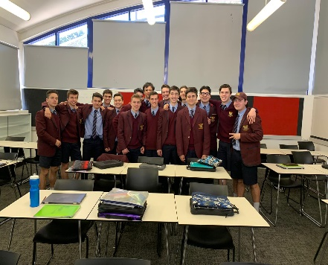

Australian life is quiet, but at the same time full of things to do and try. The school doesn’t start very early in the morning and ends early in the afternoon and, not being particularly demanding, in the afternoon I had the opportunity to socialize with other boys, do sports or any other kinds of activities.

The Marcellin College is a boys only college but this was not a problem because the boys are very close to each other and I really appreciated the involvement of all the classmates,

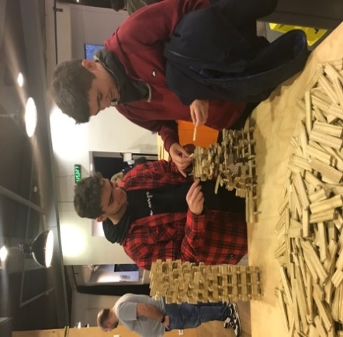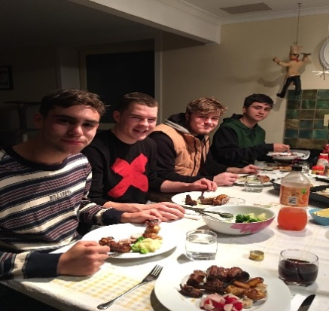

I also really enjoyed trying new fantastic sports such as rugby and unusual subjects for an Italian student, such as engineering .
Today I miss that sarcastic and always playful vein that I encountered with them in class , with which it seems so easy to make friends immediately.

I met a lot of new friends. I shared so much with all of them and through this exchange I have been able to learn so much besides having constantly spoken in English. We have established a beautiful relationship and, like most Australians, they are kind and helpful people.

In the evening instead, I enjoyed spending time with the family , dining with them, chatting,
watching a movie, playing pool, chess or briscola.

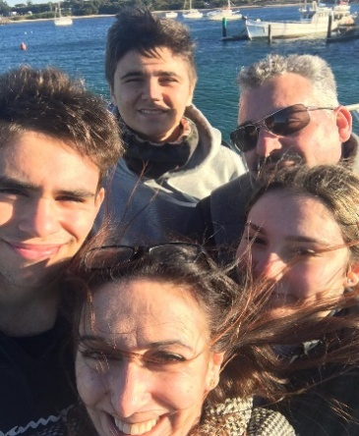

The Marcellin College, together with the Sardinian Cultural Association in Australia , gave me the opportunity to visit Canberra for an entire weekend , with an interesting guided tour of the Parliament .
I know that I will miss this infinitely: I recommend to anyone who has the opportunity to have an experience like mine!
Now here I am, back in Italy, after a few months. During this extraordinary experience I grew up and learned to make my own decisions without the support of my family.
The most important moment of my whole stay abroad took place at the airport. It is a moment that I have still imprinted in my mind: At that moment I really understood the lasting bond between myself and my host family.
I thank Mr Lostia , President of the Sardinian Cultural Association , Mr Camarda, professor of Marcellin College and Ms Woolgar for making it possible for this to happen .
It is a memory that I will carry in my heart forever and I look forward to welcoming Matthew into my family , in my school , among my friends , in my rugby team , sports that I met there and immediately put into practice on my return to Italy.

Alessandro

