CC/MM : Marcellin Melbourne / Convitto Cagliari
- Matthew Broggian: 26 Novenber, 2019 - 10 January, 2020

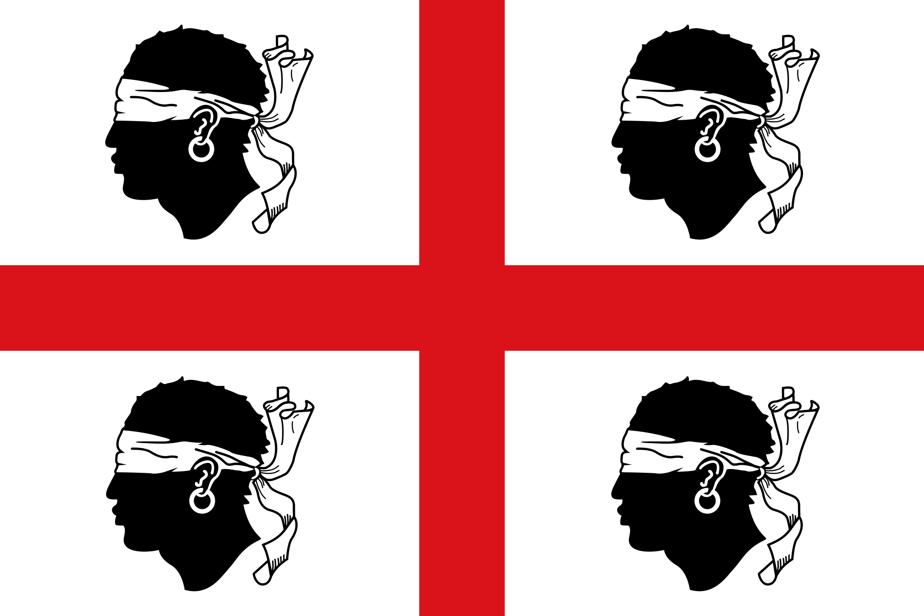

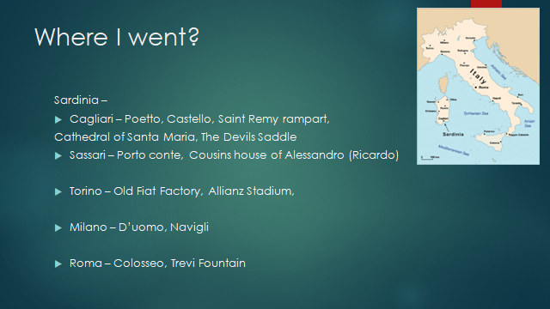

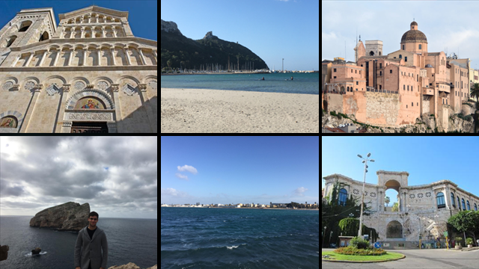

Matthew

Matthew

